Science and Art, SciArt: Museums, Laboratories, Scientists and Artists
Call for Papers MIDAS – issue 5

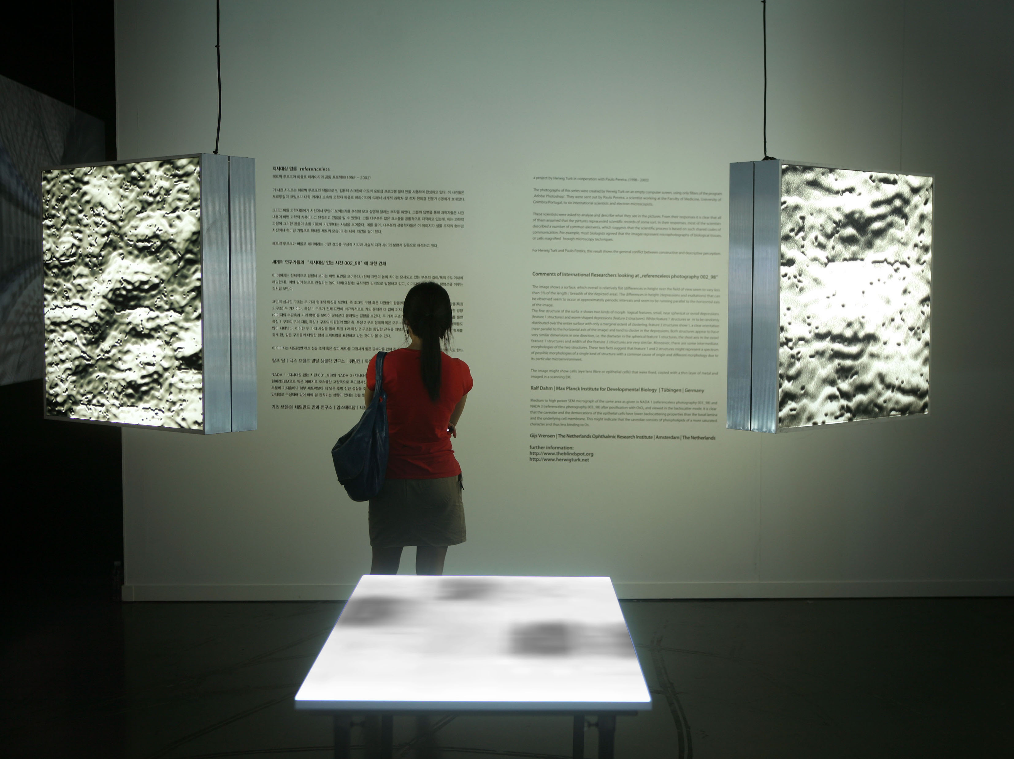
Installation view “Turn and Widen” © Herwig Turk

MIDAS – Museum Interdisciplinary Studies is launching a call for papers for issue 5 for publication in Spring 2015. This issue will include a thematic dossier under the theme “Science and Art, SciArt: Museums, Laboratories, Scientists and Artists” with Marta Agostinho, Pedro Casaleiro and Herwig Turk as guest editors.

All accepted articles will undergo a double peer-review. Articles should not exceed 6 000 words (without bibliography) or ca. 40 000 characters (with spaces). It must follow the classical structure of an academic paper. Articles should include abstract, keywords and the biography of the author(s). More information at: http://midas.revues.org/390?lang=en

Deadline: October 31, 2014. Send your text to: revistamidas@gmail.com

Science and Art, SciArt: Museums, Laboratories, Scientists and Artists
The partnership between scientists and artists in a project to produce a work of art that may communicate science is called SciART. "The meeting between two forms of [production] of knowledge, by the humanities more related to qualitative research, and by science more linked to quantitative research, seeks to reconcile opposing views, leading to transcend their differences, from which results in a mutual enrichment." One could say that it creates a new dimension, framed on a basis of co-production.
After a phase when art was limited to a representation of science, in a relationship, which despite critical and poetic was essentially based on the form, we switched to the fusion of science and art. Are we dealing with artists who become scientists using scientific knowledge as a creation media, or before scientists who become artists while creating art using science? This collaboration involves sharing and often the need for facilitation and mediation.
With this challenge we aim at the production of articles that cast a critical eye on the creative path of the interaction of science with art to create a media as a co-production process.
Themes
We highlight three preferred approaches for analysis:
- the working relationships between artists, scientists and mediators of science in the process of artistic creation;
- the museum, the gallery of science and art, the centre for research, the laboratory as venues where the works find their specific place and significance;
- the significance of these works in the museum context of science communication.
Brief CVs of guest editors:
Marta Agostinho is a science communicator. She has expertise in coordinating national and international projects of outreach, public dialogue with science, SciArt, strategic communication and research management. Marta has a PhD in Biomedical Sciences (Universidade de Lisboa, Portugal) and a post graduation in Science Communication (Open University, UK). She has been involved in the creation of the Communications and Advanced Training Unit of Instituto de Medicina Molecular (IMM) in Lisbon, acting as Unit Director and leading the Science In Society and Strategic Communication programmes (2007-2012). Currently at the coordination of a wide European consortia and teacher of advanced training modules in Faculdade de Ciências Médicas, Universidade Nova de Lisboa, Marta Agostinho is also expert evaluator for the European Commission (FP7; H2020). Marta got involved with SciArt at IMM as tutor of an artistic residency and has not stopped since then, having collaborated with the artist Herwig Turk in projects such as “The conversation that never took place”, “Tacit Knowledge #1/2” and “Hands-on”.
Herwig Turk is a SciArt artist and Lecturer at University of Applied Arts Vienna, Austria. His projects probe the interconnectivity of the fields of art, technology and science. From 2010 to 2013 he has been artist in residence at the Instituto da Medicina Molecular (IMM), Lisbon. From 2003 to 2009, Turk worked together with Paulo Pereira, head of the Department of Ophthalmology at Instituto Biomédico de Investigação da Luz e Imagem (IBILI) at the Universidade de Coimbra. In recent years, his work has been shown at venues such as the Museum of Applied Arts, Vienna, the Seoul Museum of Art, South Corea, the Neues Museum Weserburg in Bremen, the Media Art Laboratory TESLA Berlin, the Galerie Georg Kargl in Vienna and the Transmediale in Berlin, to mention only these. Herwig Turk is currently working on a monographic exhibition for the Carinthian Museum of Modern Art (MMKK), in Klagenfurt, Austria.
Pedro Casaleiro is a museologist of the Science Museum, Coimbra University, Professor of museology in the Faculty of Arts of the same university, and co-editor of MIDAS. He has expertise in coordinating projects of new museums, developing work in the areas of collections management, visitor studies, contents and exhibition development. Holds a PhD in Museum Studies (University of Leicester, UK), an MSc also in Museums in the same University, his first degree is in Biology at Lisbon University. Pedro Casaleiro worked in the National Museum of Natural History and Science in Lisbon, Lisbon Expo’98 Pavilion of the Future, Pavilion of Knowledge Ciência Viva, and since 2003 while involved in the project of the Science Museum that started with the Laboratorio Chimico, he has been dedicated to the issues of science communication and science and art. He participated in several international projects including the Portuguese Pavilion at Expo Zaragoza 2008, as a member of the scientific council, and contents advisor of the Portuguese Pavilion in Shanghai, Expo 2010.

